Knowledge Organiser
Topic: Everyday Materials | Year 2 | Strand: Chemistry
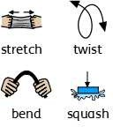
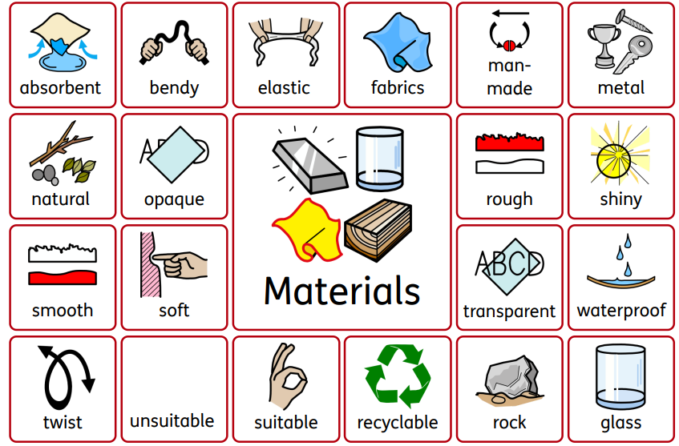

- Objects are things that you can touch or see.
- Objects are made from materials.
- Some materials that objects are made from (e.g. glass, wood, plastic)
- Some words to describe materials (e.g. shiny, soft, rough absorbent)
- Materials which are natural and which are man-made.
What should I already know?
Vocabulary
Absorbent | material that soaks up liquid easily
bendy | an object that bends easily into a curved shape
brick | rectangular blocks of baked clay used for building walls, which are usually red or brown
dull | a colour or light that is not bright
elastic | a rubber material that stretches when you pull it and  returns to its original size and shape when you let it go
fabrics | cloth or other material produced by weaving together cotton, wool or other threads.
foil | sheets of metal as thin as paper
glass | a hard transparent material
man-made | things are created by people
metal | a hard substance such as iron, steel, gold, or lead
natural | things that exist in nature and are not made by people
opaque | if an object or substance is opaque, you cannot see through it
plastic | a material which is light in weight and does not break  easily
process | a series of actions used to produce something or reach a  goal.
properties | the qualities or features that belong to something and  make it recognisable
purpose | the reason for which it is made or done
recyclable | waste or materials which can be processed and used  again
rock | the hard substance which the Earth is made of
rough | uneven and not smooth
shiny | things are bright and reflect light
smooth | no roughness, lumps, or holes
soft | not rough or hard
squash | pressed or crushed with such force that something loses  its shape
stiff | firm or does not bend easily
stretchy | slightly elastic
suitable | something that is suitable for a particular purpose or  occasion is right or acceptable for it
transparent | If an object is transparent, you can see through it
twist | turn something to make a spiral shape
unsuitable | Someone or something that is unsuitable for a particular  purpose or situation does not have the right properties  for it
waterproof | does not let water pass through it
wood | the material which forms the trunks and branches of trees

What will I know by the end of the unit?
What are materials used for? | - Materials are used for different purposes based on their properties.  - For example, wood is used to make furniture and floors.  - Metal can be used to make coins, cans, cars and cutlery.  - Glass can used to make windows.  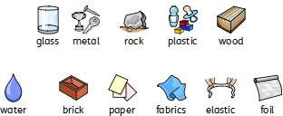
What properties of  materials make them suitable for a particular use? | - Glass can used to make windows because it is  transparent.  - Rulers can be made from wood, plastic or rubber because these materials are smooth and can be cut straight.  - Spoons are made from metal, because it is  waterproof and can be cleaned easily.  - They can also be made from plastic for children because plastic is light and it cannot hurt  children’s growing teeth.  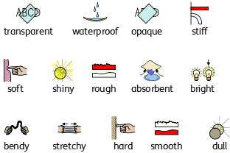
How can you change the shape of  materials? | - The shape of some materials can be changed when they are stretched, twisted, bent and  squashed.

